Performing and Undertaking Network Meta-Analysis: Solutions

R packages
library(readxl)
library(dplyr)
library(netmeta)
settings.meta(digits = 2)

Datasets

Acute mania dataset
AcuteMania = read_excel("AcuteMania.xls")
AcuteMania = as.data.frame(AcuteMania)
str(AcuteMania)
## 'data.frame': 105 obs. of 5 variables:
## $ treatment: chr "ARI" "PLA" "ARI" "PLA" ...
## $ r : num 155 63 72 42 89 72 49 23 110 49 ...
## $ n : num 253 131 137 135 175 172 130 132 267 134 ...
## $ studyid : num 1 1 2 2 3 3 4 4 5 5 ...
## $ rob : num 2 2 2 2 2 2 2 2 2 2 ...

Analysis of the network comparing antimanic drugs
Which treatment is the most frequently studied?
table(AcuteMania$treatment)
##
## ARI ASE CARB DIV HAL LAM LITH OLA PAL PLA QUE RIS TOP ZIP
## 7 1 3 8 8 1 8 13 2 36 7 5 1 5
Olanzapine (OLA) was evaluated in 13 studies.
How many studies have more than two arms?
table(table(AcuteMania$studyid))
##
## 2 3
## 36 11
Eleven studies had more than two arms (all three-arm studies).
Transform data from long to contrast-based format using the pairwise function.
AcuteManiaPair = pairwise(treat = treatment, event = r, n = n,
data = AcuteMania, studlab = studyid, sm = "OR")
Now compare the two datasets.
subset(AcuteMania, studyid < 4)
## treatment r n studyid rob
## 1 ARI 155 253 1 2
## 2 PLA 63 131 1 2
## 3 ARI 72 137 2 2
## 4 PLA 42 135 2 2
## 5 ARI 89 175 3 2
## 6 HAL 72 172 3 2
subset(AcuteManiaPair, studyid < 4) %>% select(1:9)
## studlab treat1 treat2 TE seTE event1 n1 event2 n2
## 1 1 ARI PLA 0.5348306 0.2173352 155 253 63 131
## 2 2 ARI PLA 0.8972087 0.2526573 72 137 42 135
## 3 3 ARI HAL 0.3627931 0.2162238 89 175 72 172
What is now presented in the new variables TE and seTE?
TE is the log odds ratio of the comparison treat1 versus treat2. seTE is the standard error of the log odds ratio.

Network plot
To plot the network you need first to create an object of class netmeta by running the command.
net1 = netmeta(AcuteManiaPair)
Then use the following netgraph command to produce a network plot
netgraph(net1)
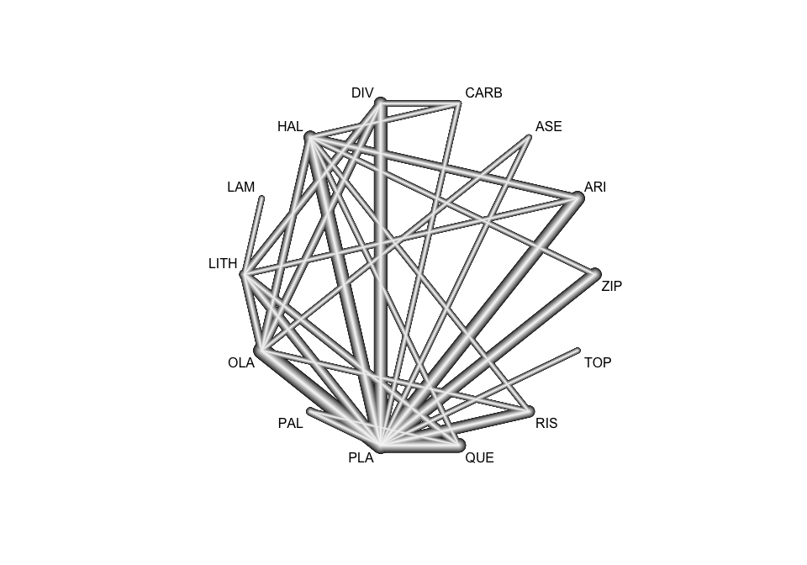
Check the help file for the netgraph command to see the options you have.
Now re-create a plot by weighting the nodes according to the number of studies evaluating each treatment.
netgraph(net1, plastic = FALSE, multiarm = FALSE,
points = TRUE, cex.points = table(AcuteMania$treatment))
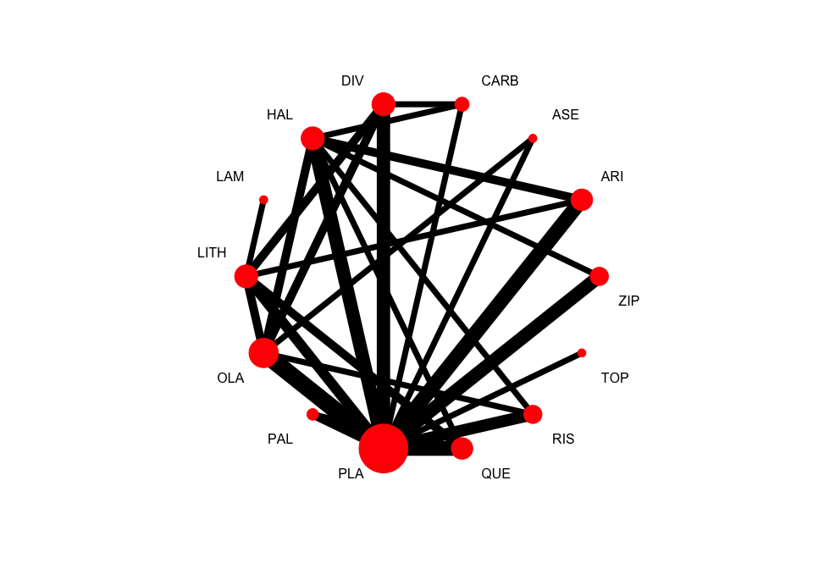
Optional: You can create 3-D plots using the rgl library.
# install.packages("rgl")
# netgraph(net1, dim = "3d", col = 1)

Performing a network meta-analysis
Let us run only a random effects network meta-analysis and use Placebo as the reference to present the results.
net1 = netmeta(AcuteManiaPair, ref = "PLA", common = FALSE)
net1
## Number of studies: k = 47
## Number of pairwise comparisons: m = 69
## Number of observations: o = 12881
## Number of treatments: n = 14
## Number of designs: d = 30
##
## Random effects model
##
## Treatment estimate (sm = 'OR', comparison: other treatments vs 'PLA'):
## OR 95%-CI z p-value
## ARI 1.99 [1.53; 2.60] 5.09 < 0.0001
## ASE 1.69 [0.91; 3.15] 1.67 0.0958
## CARB 2.47 [1.36; 4.49] 2.97 0.0029
## DIV 1.98 [1.43; 2.72] 4.17 < 0.0001
## HAL 2.25 [1.72; 2.95] 5.87 < 0.0001
## LAM 1.35 [0.28; 6.58] 0.37 0.7116
## LITH 1.77 [1.25; 2.51] 3.19 0.0014
## OLA 2.18 [1.73; 2.75] 6.55 < 0.0001
## PAL 1.72 [1.09; 2.73] 2.33 0.0199
## PLA . . . .
## QUE 1.94 [1.46; 2.58] 4.58 < 0.0001
## RIS 2.36 [1.70; 3.28] 5.13 < 0.0001
## TOP 0.78 [0.35; 1.72] -0.62 0.5338
## ZIP 1.37 [0.99; 1.89] 1.92 0.0553
##
## Quantifying heterogeneity / inconsistency:
## tau^2 = 0.0759; tau = 0.2755; I^2 = 49.1% [28.3%; 63.9%]
##
## Tests of heterogeneity (within designs) and inconsistency (between designs):
## Q d.f. p-value
## Total 88.39 45 0.0001
## Within designs 33.62 17 0.0094
## Between designs 54.77 28 0.0018
What does the output matrix show?
The matrix shows the odds ratios of active treatments versus Placebo.
Which drug presents the largest response rate compared to Placebo?
The largest odds ratio is observed for Carbamazepine (CARB).
How much is the heterogeneity? How has it been estimated and under which assumptions?
The between-study variance tau2 is estimated using a generalised DerSimonian-Laird method under the assumption that tau2 is the same for all pairwise comparisons.
To see the estimates for placebo versus drug simply set the argument baseline.reference = FALSE.
net1 = netmeta(AcuteManiaPair, ref = "PLA", common = FALSE,
baseline.reference = FALSE)
net1
## Number of studies: k = 47
## Number of pairwise comparisons: m = 69
## Number of observations: o = 12881
## Number of treatments: n = 14
## Number of designs: d = 30
##
## Random effects model
##
## Treatment estimate (sm = 'OR', comparison: 'PLA' vs other treatments):
## OR 95%-CI z p-value
## ARI 0.50 [0.38; 0.65] -5.09 < 0.0001
## ASE 0.59 [0.32; 1.10] -1.67 0.0958
## CARB 0.40 [0.22; 0.73] -2.97 0.0029
## DIV 0.51 [0.37; 0.70] -4.17 < 0.0001
## HAL 0.44 [0.34; 0.58] -5.87 < 0.0001
## LAM 0.74 [0.15; 3.62] -0.37 0.7116
## LITH 0.57 [0.40; 0.80] -3.19 0.0014
## OLA 0.46 [0.36; 0.58] -6.55 < 0.0001
## PAL 0.58 [0.37; 0.92] -2.33 0.0199
## PLA . . . .
## QUE 0.52 [0.39; 0.68] -4.58 < 0.0001
## RIS 0.42 [0.30; 0.59] -5.13 < 0.0001
## TOP 1.29 [0.58; 2.84] 0.62 0.5338
## ZIP 0.73 [0.53; 1.01] -1.92 0.0553
##
## Quantifying heterogeneity / inconsistency:
## tau^2 = 0.0759; tau = 0.2755; I^2 = 49.1% [28.3%; 63.9%]
##
## Tests of heterogeneity (within designs) and inconsistency (between designs):
## Q d.f. p-value
## Total 88.39 45 0.0001
## Within designs 33.62 17 0.0094
## Between designs 54.77 28 0.0018
There are some small numerical differences to the ORs reported in the paper. Why?
R package netmeta is a frequentist method while Cipriani et al. (2011) used a Bayesian method. Furthermore, the estimators of tau2 differ.
Several elements are stored under the net1 object.
The heterogeneity standard deviation is estimated as
round(net1$tau, 3)
## [1] 0.276
and I-squared (total) is
paste0(round(100 * net1$I2), "%")
## [1] "49%"

Presenting the results from a network meta-analysis

League table
To obtain a league table using the NMA object net1 use the netleague function.
leaguetable = netleague(net1)
leaguetable
## League table (random effects model):
##
## ARI . . .
## 1.18 [0.60; 2.30] ASE . .
## 0.81 [0.42; 1.54] 0.69 [0.29; 1.62] CARB 0.42 [0.08; 2.10]
## 1.01 [0.67; 1.52] 0.86 [0.43; 1.69] 1.25 [0.65; 2.41] DIV
## 0.88 [0.64; 1.23] 0.75 [0.39; 1.46] 1.10 [0.58; 2.09] 0.88 [0.58; 1.32]
## 1.48 [0.30; 7.31] 1.26 [0.23; 6.86] 1.83 [0.34; 9.95] 1.47 [0.29; 7.32]
## 1.13 [0.75; 1.70] 0.96 [0.47; 1.93] 1.40 [0.70; 2.78] 1.12 [0.72; 1.74]
## 0.91 [0.65; 1.29] 0.78 [0.42; 1.43] 1.14 [0.60; 2.14] 0.91 [0.64; 1.28]
## 1.16 [0.68; 1.96] 0.98 [0.45; 2.12] 1.43 [0.68; 3.04] 1.15 [0.66; 2.00]
## 1.99 [1.53; 2.60] 1.69 [0.91; 3.15] 2.47 [1.36; 4.49] 1.98 [1.43; 2.72]
## 1.03 [0.70; 1.50] 0.87 [0.44; 1.72] 1.27 [0.66; 2.46] 1.02 [0.67; 1.55]
## 0.84 [0.56; 1.28] 0.72 [0.36; 1.43] 1.05 [0.53; 2.06] 0.84 [0.53; 1.31]
## 2.56 [1.11; 5.90] 2.18 [0.80; 5.95] 3.18 [1.18; 8.56] 2.54 [1.08; 5.97]
## 1.45 [0.96; 2.19] 1.23 [0.61; 2.48] 1.80 [0.92; 3.54] 1.44 [0.92; 2.27]
##
## 1.16 [0.71; 1.89] . 1.09 [0.54; 2.19] .
## . . . 0.69 [0.35; 1.35]
## 0.80 [0.11; 5.82] . . .
## . . 0.78 [0.32; 1.92] 0.77 [0.47; 1.27]
## HAL . . 1.21 [0.67; 2.16]
## 1.67 [0.34; 8.30] LAM 0.76 [0.16; 3.57] .
## 1.27 [0.83; 1.95] 0.76 [0.16; 3.57] LITH 0.62 [0.26; 1.50]
## 1.03 [0.75; 1.43] 0.62 [0.13; 3.05] 0.81 [0.55; 1.20] OLA
## 1.31 [0.77; 2.21] 0.78 [0.15; 4.05] 1.03 [0.58; 1.80] 1.26 [0.76; 2.11]
## 2.25 [1.72; 2.95] 1.35 [0.28; 6.58] 1.77 [1.25; 2.51] 2.18 [1.73; 2.75]
## 1.16 [0.80; 1.68] 0.69 [0.14; 3.42] 0.91 [0.61; 1.35] 1.12 [0.78; 1.61]
## 0.95 [0.64; 1.42] 0.57 [0.11; 2.87] 0.75 [0.47; 1.20] 0.92 [0.64; 1.33]
## 2.90 [1.25; 6.69] 1.73 [0.29; 10.19] 2.28 [0.96; 5.41] 2.80 [1.23; 6.39]
## 1.64 [1.11; 2.43] 0.98 [0.20; 4.95] 1.29 [0.80; 2.07] 1.59 [1.07; 2.35]
##
## . 1.77 [1.32; 2.37] . .
## . 2.04 [0.96; 4.35] . .
## . 3.10 [1.58; 6.09] . .
## . 2.16 [1.48; 3.18] . .
## . 2.26 [1.58; 3.23] 1.72 [0.79; 3.73] 0.95 [0.47; 1.93]
## . . . .
## . 2.28 [1.43; 3.64] 0.70 [0.39; 1.25] .
## . 1.90 [1.43; 2.52] . 1.20 [0.60; 2.40]
## PAL 1.57 [0.96; 2.59] 1.25 [0.64; 2.45] .
## 1.72 [1.09; 2.73] PLA 0.51 [0.37; 0.69] 0.40 [0.27; 0.58]
## 0.89 [0.55; 1.45] 0.52 [0.39; 0.68] QUE .
## 0.73 [0.42; 1.28] 0.42 [0.30; 0.59] 0.82 [0.53; 1.26] RIS
## 2.22 [0.89; 5.53] 1.29 [0.58; 2.84] 2.50 [1.08; 5.79] 3.04 [1.29; 7.15]
## 1.26 [0.72; 2.20] 0.73 [0.53; 1.01] 1.42 [0.92; 2.17] 1.72 [1.09; 2.72]
##
## . .
## . .
## . .
## . .
## . 2.05 [1.03; 4.08]
## . .
## . .
## . .
## . .
## 1.29 [0.58; 2.84] 0.68 [0.48; 0.95]
## . .
## . .
## TOP .
## 0.57 [0.24; 1.33] ZIP
You can export a league table in a .csv file
write.csv(leaguetable$random, "leaguetable-random.csv",
row.names = FALSE)
This file can be opened, for example, with Excel or LibreOffice.
Optional: You can also directly export a league table to an Excel file (R package writeXL must be installed).
# netleague(net1, digits = 2, path = "leaguetable-random.xlsx")

Forest plots
forest(net1)
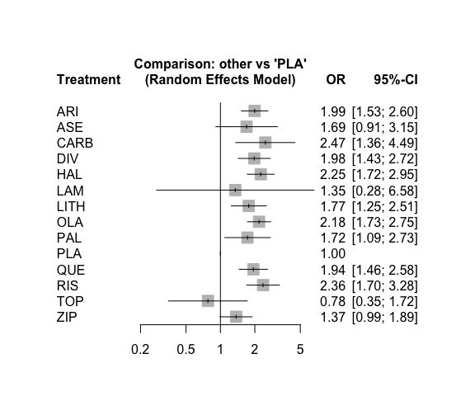
Which are the three most effective interventions compared to placebo?
The largest odds ratios are observed for Carbamazepine (CARB), Haloperidol (HAL) and Risperidone (RIS).
forest(net1, ref = "HAL")
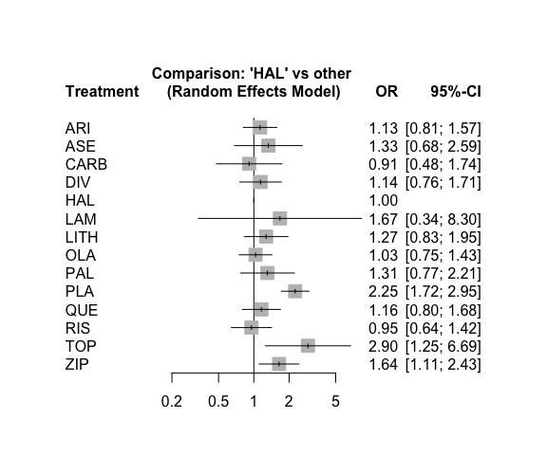
Are there any differences between active interventions?
Haloperidol (HAL) is more effective than Topiramate (TOP) and Ziprasidone (ZIP).
It is always useful to see the effect sizes in a consistent order, e.g. decreasing
forest(net1, sortvar =TE)
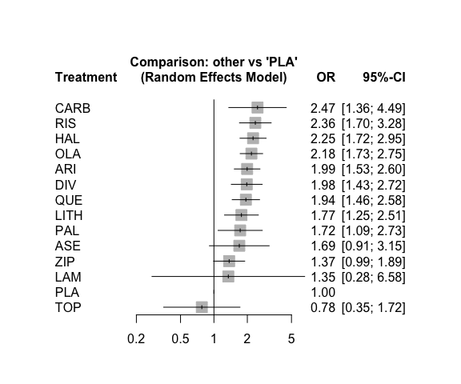
The variable ‘k’ stored in net1 contains the number of direct comparisons. We can plot them in the forest plot.
forest(net1, sortvar = TE,
leftcols = c("studlab", "k"),
leftlabs = c("Drug", "Direct\nstudies"),
xlab = "Response to treatment",
smlab = "NMA random effects")
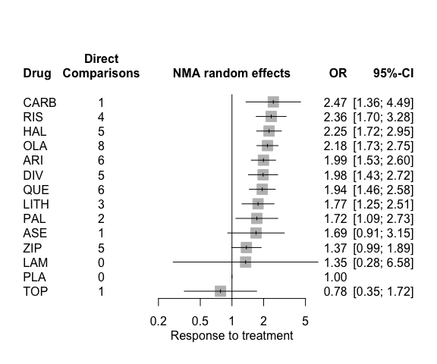

Ranking treatments
netrank(net1, small = "bad")
## P-score
## RIS 0.8002
## CARB 0.7873
## HAL 0.7608
## OLA 0.7227
## ARI 0.6007
## DIV 0.5918
## QUE 0.5715
## LITH 0.4643
## PAL 0.4552
## ASE 0.4551
## LAM 0.3852
## ZIP 0.2492
## PLA 0.0905
## TOP 0.0655
Which intervention has the highest probability of “beating” all other treatments?
Risperidone (RIS) has the highest probability, however, Carbamazepine (CARB) and Haloperidol (HAL) have very similar probabilities.
You can even add the P-scores in the forest plot and sort the summary ORs accordingly:
forest(net1,
rightcols = c("effect", "ci", "Pscore"),
rightlabs = "P-Score", sortvar = -Pscore, small = "bad",
xlab = "Response to treatment",
smlab = "Active drug vs placebo")
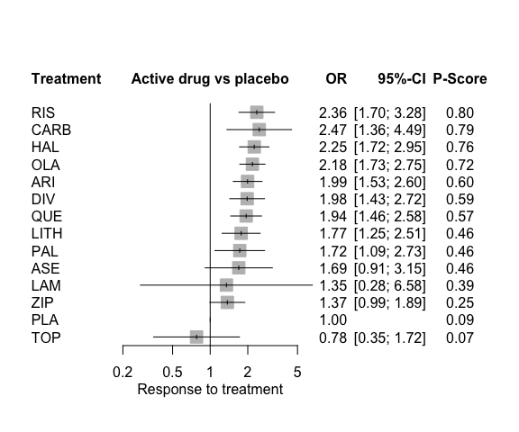

Sensitivity analysis
Let us perform a network meta-analysis using studies only at low risk of bias.
table(AcuteManiaPair$rob)
##
## 1 2
## 19 50
net2 = netmeta(AcuteManiaPair, ref = "PLA", common = FALSE,
subset = rob == 1)
net2
## Number of studies: k = 13
## Number of pairwise comparisons: m = 19
## Number of observations: o = 3440
## Number of treatments: n = 9
## Number of designs: d = 11
##
## Random effects model
##
## Treatment estimate (sm = 'OR', comparison: other treatments vs 'PLA'):
## OR 95%-CI z p-value
## DIV 2.05 [1.21; 3.46] 2.68 0.0073
## HAL 3.16 [1.72; 5.82] 3.69 0.0002
## LITH 2.46 [0.91; 6.64] 1.77 0.0768
## OLA 2.23 [1.41; 3.54] 3.42 0.0006
## PAL 1.14 [0.51; 2.55] 0.31 0.7557
## PLA . . . .
## RIS 1.75 [0.68; 4.52] 1.16 0.2459
## TOP 0.78 [0.32; 1.92] -0.55 0.5855
## ZIP 1.84 [1.10; 3.08] 2.33 0.0198
##
## Quantifying heterogeneity / inconsistency:
## tau^2 = 0.1251; tau = 0.3537; I^2 = 56.8% [9.2%; 79.5%]
##
## Tests of heterogeneity (within designs) and inconsistency (between designs):
## Q d.f. p-value
## Total 18.52 8 0.0176
## Within designs 3.59 2 0.1661
## Between designs 14.93 6 0.0208
As you see only 9 of 14 treatments and 19 of 69 pairwise comparisons are represented in this subnetwork.
Is there evidence that the network that includes only low risk of bias studies is more homogeneous?
No, both tau2 and I2 increased compared to the network meta-analysis of all studies.

Inconsistency evaluation in acute mania dataset
First, we print the number of designs
net1$d
## [1] 30
and the list of all designs (to see how many designs have two and three studies)
net1$designs
## [1] "ARI:HAL" "ARI:HAL:PLA" "ARI:LITH:PLA" "ARI:PLA" "ASE:OLA:PLA"
## [6] "CARB:DIV" "CARB:HAL" "CARB:PLA" "DIV:LITH" "DIV:LITH:PLA"
## [11] "DIV:OLA" "DIV:OLA:PLA" "DIV:PLA" "HAL:OLA" "HAL:OLA:PLA"
## [16] "HAL:PLA:QUE" "HAL:PLA:RIS" "HAL:PLA:ZIP" "LAM:LITH" "LITH:OLA"
## [21] "LITH:PLA:QUE" "LITH:QUE" "OLA:PLA" "OLA:RIS" "PAL:PLA"
## [26] "PAL:PLA:QUE" "PLA:QUE" "PLA:RIS" "PLA:TOP" "PLA:ZIP"
We see that the acute mania dataset contains 30 designs of which 11 are three-arm designs.
Next, we apply the SIDE method and print the results for the random effects model.
split1 = netsplit(net1)
print(split1, show = "both", digits = 2)
## Separate indirect from direct evidence (SIDE) using back-calculation method
##
## Random effects model:
##
## comparison k prop nma direct indir. RoR z p-value
## ARI:HAL 2 0.46 0.88 1.16 0.70 1.65 1.48 0.1398
## ARI:LITH 1 0.34 1.13 1.09 1.15 0.95 -0.12 0.9044
## ARI:PLA 6 0.83 1.99 1.77 3.55 0.50 -1.93 0.0534
## ASE:OLA 1 0.82 0.78 0.69 1.37 0.50 -0.85 0.3938
## ASE:PLA 1 0.67 1.69 2.04 1.15 1.78 0.85 0.3938
## CARB:DIV 1 0.16 1.25 0.42 1.55 0.27 -1.46 0.1455
## CARB:HAL 1 0.11 1.10 0.80 1.14 0.70 -0.33 0.7415
## CARB:PLA 1 0.78 2.47 3.10 1.10 2.83 1.41 0.1579
## DIV:LITH 2 0.25 1.12 0.78 1.25 0.62 -0.90 0.3704
## DIV:OLA 2 0.48 0.91 0.77 1.06 0.73 -0.89 0.3712
## DIV:PLA 5 0.70 1.98 2.16 1.60 1.35 0.85 0.3955
## HAL:OLA 2 0.31 1.03 1.21 0.97 1.25 0.62 0.5363
## HAL:PLA 5 0.57 2.25 2.26 2.24 1.01 0.03 0.9753
## HAL:QUE 1 0.23 1.16 1.72 1.03 1.66 1.12 0.2612
## HAL:RIS 1 0.31 0.95 0.95 0.96 0.99 -0.01 0.9902
## HAL:ZIP 1 0.32 1.64 2.05 1.48 1.38 0.76 0.4468
## LITH:OLA 2 0.20 0.81 0.62 0.87 0.72 -0.67 0.5050
## LITH:PLA 3 0.56 1.77 2.28 1.28 1.78 1.60 0.1100
## LITH:QUE 2 0.47 0.91 0.70 1.15 0.61 -1.22 0.2242
## OLA:PLA 8 0.67 2.18 1.90 2.89 0.66 -1.66 0.0971
## OLA:RIS 1 0.28 0.92 1.20 0.83 1.45 0.89 0.3750
## PAL:PLA 2 0.85 1.72 1.57 2.85 0.55 -0.92 0.3601
## PAL:QUE 1 0.53 0.89 1.25 0.60 2.08 1.47 0.1426
## QUE:PLA 6 0.83 1.94 1.98 1.77 1.12 0.29 0.7724
## RIS:PLA 4 0.74 2.36 2.51 1.99 1.26 0.60 0.5503
## ZIP:PLA 5 0.91 1.37 1.48 0.63 2.33 1.46 0.1447
##
## Legend:
## comparison - Treatment comparison
## k - Number of studies providing direct evidence
## prop - Direct evidence proportion
## nma - Estimated treatment effect (OR) in network meta-analysis
## direct - Estimated treatment effect (OR) derived from direct evidence
## indir. - Estimated treatment effect (OR) derived from indirect evidence
## RoR - Ratio of Ratios (direct versus indirect)
## z - z-value of test for disagreement (direct versus indirect)
## p-value - p-value of test for disagreement (direct versus indirect)
How do you interpret the results? Are there any large discrepancies between the direct and indirect estimates?
As the columns ‘RoR’, ‘z’, and ‘p-value’ indicate there is no single pairwise comparison showing large inconsisteny between direct and indirect evidence.
Finally, we look at the design-by-treatment interaction model.
decomp.design(net1)
## Q statistics to assess homogeneity / consistency
##
## Q df p-value
## Total 88.39 45 0.0001
## Within designs 33.62 17 0.0094
## Between designs 54.77 28 0.0018
##
## Design-specific decomposition of within-designs Q statistic
##
## Design Q df p-value
## LITH:OLA 2.71 1 0.0995
## PLA:ARI 7.32 3 0.0623
## PLA:DIV 3.38 2 0.1842
## PLA:OLA 6.88 4 0.1426
## PLA:QUE 1.66 2 0.4350
## PLA:RIS 6.73 2 0.0345
## PLA:ZIP 4.93 3 0.1771
##
## Between-designs Q statistic after detaching of single designs
##
## Detached design Q df p-value
## ARI:HAL 48.70 27 0.0064
## CARB:DIV 51.94 27 0.0027
## CARB:HAL 54.51 27 0.0013
## DIV:LITH 51.82 27 0.0028
## DIV:OLA 51.67 27 0.0029
## HAL:OLA 54.68 27 0.0013
## LITH:OLA 54.11 27 0.0015
## LITH:QUE 49.78 27 0.0048
## OLA:RIS 52.71 27 0.0022
## PLA:ARI 54.23 27 0.0014
## PLA:CARB 51.97 27 0.0027
## PLA:DIV 54.18 27 0.0014
## PLA:OLA 54.27 27 0.0014
## PLA:PAL 48.07 27 0.0075
## PLA:QUE 54.33 27 0.0014
## PLA:RIS 51.38 27 0.0031
## PLA:ZIP 54.77 27 0.0012
## PLA:ARI:HAL 51.92 26 0.0018
## PLA:ARI:LITH 54.34 26 0.0009
## PLA:DIV:LITH 51.82 26 0.0019
## PLA:DIV:OLA 52.20 26 0.0017
## PLA:HAL:OLA 50.78 26 0.0025
## PLA:HAL:QUE 52.09 26 0.0018
## PLA:HAL:RIS 53.82 26 0.0011
## PLA:HAL:ZIP 47.87 26 0.0056
## PLA:LITH:QUE 49.80 26 0.0033
## PLA:PAL:QUE 47.93 26 0.0055
##
## Q statistic to assess consistency under the assumption of
## a full design-by-treatment interaction random effects model
##
## Q df p-value tau.within tau2.within
## Between designs 28.27 28 0.4503 0.2861 0.0819
How do you interpret the overall results (Q statistics)?
The overall Q statistics show that both within-design heterogeneity and between-design inconsistency exists.
Which individual comparison contributes most to the within-design heterogeneity?
The comparison ‘PLA:RIS’ contributes most to the within-design heterogenity.
Which designs show the largest between-design inconsistency?
The designs ‘ARI:HAL’ and ‘PLA:PAL’ have the largest p-values for the between-designs Q statistic after detaching a single design. Accordingly, these two designs contribute most to the inconsistency in the network.

