Supplemental Table. Example of Evidence to Decision Framework. Adapted from [1].

Question
Should Pirfenidone vs. placebo be used for patients with Idiopathic pulmonary fibrosis?
Population: |  | Patients with IPF |  | Background: | Idiopathic pulmonary fibrosis (IPF) is a specific form of chronic, progressive fibrosing interstitial pneumonia of unknown cause occurring in adults with radiologic and/or histopathologic patterns consistent with usual interstitial pneumonia. A number of risk factors have been suggested (environmental and genetic) as cause of IPF. Disease features differ and treatment options are plenty although most of them not providing clear health benefits. Pirfenidone is a newer agent investigated in several trials in patients with IPF.
Intervention: |  | Pirfenidone
Comparison: |  | Placebo
Main outcomes: |  | - Mortality (critical)  - Acute exacerbation (critical)  - Disease progression (critical)  - Disease Progression (critical)  - Oxygen saturation (higher numbers are better) (important)  - Photosensitivity (important)  - Anorexia (important)  - Fatigue (important)  - Stomach discomfort (important)
Setting: |  | Inpatients and outpatients
Perspective: |  | Population

Assessment
 | Criteria |  | Judgements | Research evidence |  | Additional considerations
Problem | Is there a problem priority? |  | ○ No  ○ Probably no  ○ Uncertain  ○ Probably yes  ● Yes  ○ Varies | There are no large-scale studies of the incidence or prevalence of IPF on which to base formal estimates. The incidence of IPF was estimated at 10.7 cases per 100,000 per year for men and 7.4 cases per 100,000 per year for women in a population-based study from the county of Bernalillo, New Mexico. A study from the United Kingdom reported an overall incidence rate of only 4.6 per 100,000 person-years, but estimated that the incidence of IPF increased by 11% annually between 1991 and 2003. This increase was not felt to be attributable to the aging of the population or increased ascertainment of milder cases. A third study from the United States estimated the incidence of IPF to be between 6.8 and 16.3 per 100,000 persons using a large database of healthcare claims in a health plan (An Official ATS/ERS/JRS/ALAT Statement: Idiopathic Pulmonary Fibrosis: Evidence-based Guidelines for Diagnosis and Management, Raghu et al. 2011). |  | There is a high mortality and morbidity associated with IPF with a small number of proven treatment options.
Benefits & harms of the options | What is the overall certainty of this evidence? |  | ○ No included studies  ○ Very low  ○ Low  ● Moderate  ○ High | 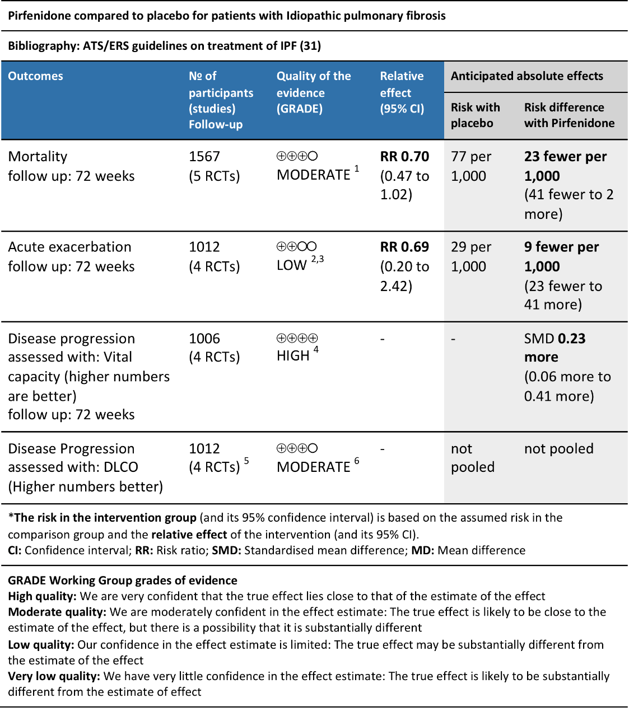 |  | FVC data from King Jr study not pooled due to reporting differences however magnitude of effect similar to other studies that were pooled.  Quality of Life was not collected. Would this have changed recommendation? Unlikely.  Photosensitivity - less of a problem if taking proper precautions.
 | Is there important uncertainty about how much people value the main outcomes? |  | ○ Important uncertainty or variability  ○ Possibly important uncertainty or variability  ○ Probably no important uncertainty or variability  ● No important uncertainty or variability  ○ No known undesirable outcomes
 | Are the desirable anticipated effects large? |  | ○ No  ○ Probably no  ○ Uncertain  ● Probably yes  ○ Yes  ○ Varies
 | Are the undesirable anticipated effects small? |  | ○ No  ○ Probably no  ○ Uncertain  ● Probably yes  ○ Yes  ○ Varies
 | Are the desirable effects large relative to undesirable effects? |  | ○ No  ○ Probably no  ○ Uncertain  ● Probably yes  ○ Yes  ○ Varies
Resource use | Are the resources required small? |  | ● No  ○ Probably no  ○ Uncertain  ○ Probably yes  ○ Yes  ○ Varies |  |  | Pirfenidone is expensive. Estimated yearly cost around $40,000/patient. In Europe around 40k euros.
 | Is the incremental cost small relative to the net benefits? |  | ● No  ○ Probably no  ○ Uncertain  ○ Probably yes  ○ Yes  ○ Varies | None identified. |  | Balancing the costs versus the net benefit, the costs still are not small.
Equity | What would be the impact on health inequities? |  | ○ Increased  ● Probably increased  ○ Uncertain  ○ Probably reduced  ○ Reduced  ○ Varies | None included. |  | Likely treatment would only be affordable to those in high-income countries.
Acceptability | Is the option acceptable to key stakeholders? |  | ● No  ○ Probably no  ○ Uncertain  ○ Probably yes  ○ Yes  ○ Varies | Non included. |  | There is uncertainty about acceptability owing to large resources required.
Feasibility | Is the option feasible to implement? |  | ○ No  ○ Probably no  ○ Uncertain  ○ Probably yes  ● Yes  ○ Varies | Non included. |  | Pirfenidone is approved in most countries and already being used for other indications.

Recommendation

Should Pirfenidone vs. placebo be used for patients with Idiopathic pulmonary fibrosis?
Balance of consequences | Undesirable consequences clearly outweigh desirable consequences in most settings | Undesirable consequences probably outweigh desirable consequences in most settings | The balance between desirable and undesirable consequences is closely balanced or uncertain | Desirable consequences probably outweigh undesirable consequences in most settings | Desirable consequences clearly outweigh undesirable consequences in most settings
 | ○ | ○ | ○ | ● | ○

Type of recommendation | We recommend against offering this option | We suggest not offering this option | We suggest offering this option | We recommend offering this option
 | ○ | ○ | ● | ○
Recommendation | We suggest pirfenidone in patients with IPF (conditional, moderate).
Justification | One panel member thought it should be a strong recommendation for using the treatment. The rationale was that the cost required is similar to costs in e.g. oncology.
Subgroup considerations | Inclusion criteria for most of the trials were relatively narrow (excluded patients with emphysema and severe PFTs) so less certainty regarding patients with severe disease but no real reason to think they would respond differently.  Patients with major comorbidities were excluded.
Implementation considerations | There is some uncertainty when the treatment should be started and when should be stopped. There is uncertainty how long does the treatment effect last. In most studies follow-up was 1y.  Shared (between clinician and patient) and informed decision making about adverse effects needs to be done as with any intervention.
Monitoring and evaluation | Drug interactions may be relevant.
Research possibilities | How long does the treatment effect last?  How long should patients be treated for?
[1] Raghu G, Rochwerg B, Zhang Y, Garcia CAC, Azuma A, Behr J, Brozek JL, Collard HR, Cunningham W, Homma S, Johkoh T, Martinez FJ, Myers J, Protzko SL, Richeldi L, Rind D, Selman M, Theodore A, Wells AU, Hoogsteden H, Schünemann HJ, American Thoracic Society, European Respiratory society, Japanese Respiratory Society, Latin American Thoracic Association. An official ATS/ERS/JRS/ALAT clinical practice guideline: treatment of idiopathic pulmonary fibrosis. An update of the 2011 clinical practice guideline. Am. J. Respir. Crit. Care Med. 2015;192(2):e3–19. doi: 10.1164/rccm.201506-1063ST.

